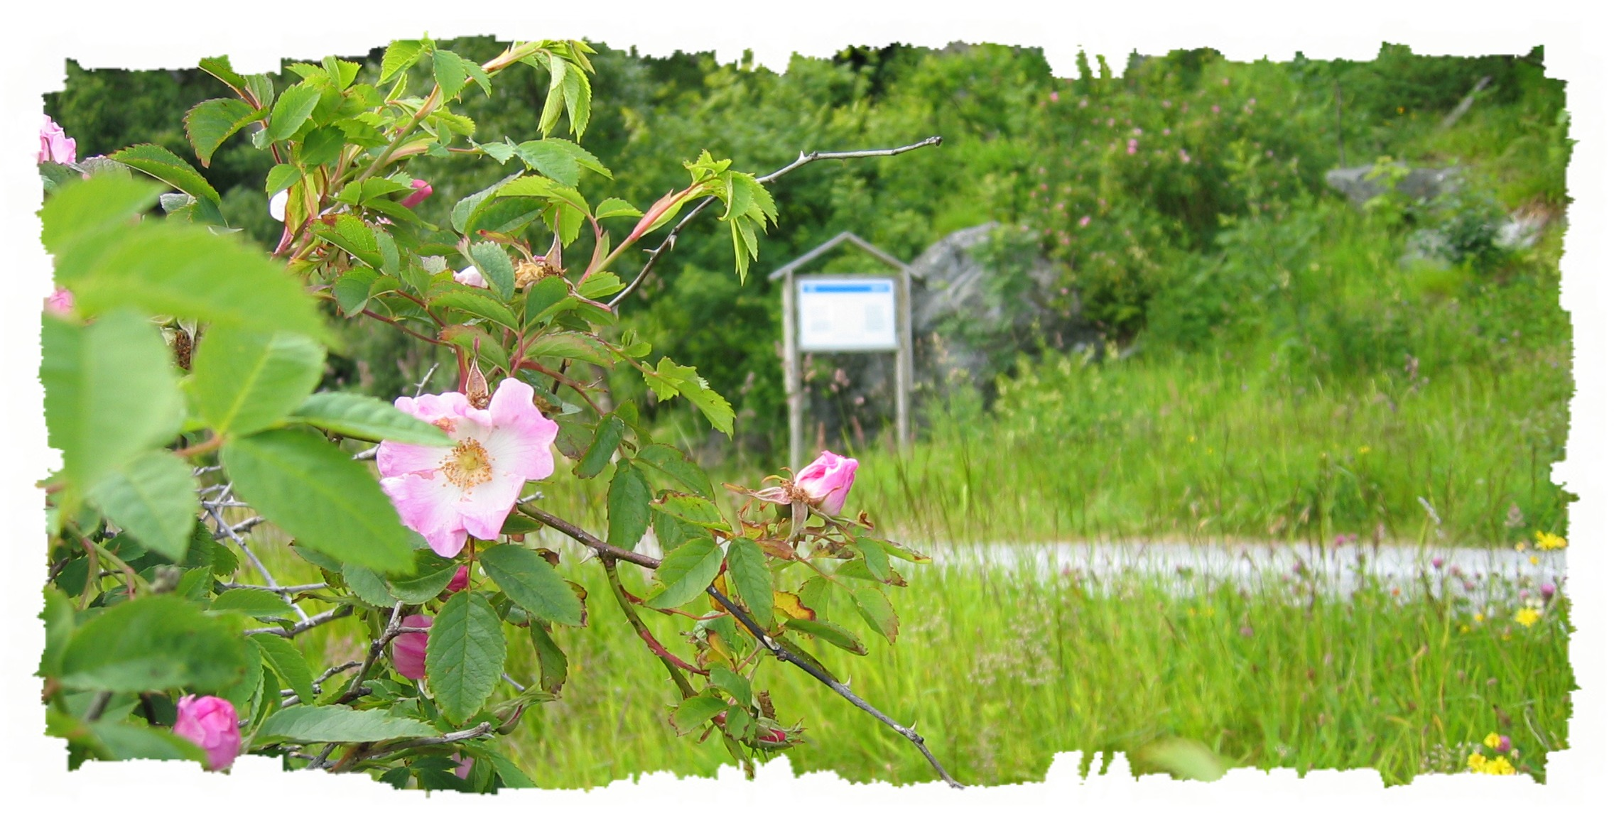

Indre Fure (Inner Fure )

Fure is divided into two farms. Indre (inner) Fure where you are now, and Ytre (outer) Fure, a one hour hike in western direction. Indre Fure was first mentioned in written sources ca. 1300-1350 AD. The houses in the country courtyards are built closely together, like they usually were in earlier days. This is the only place on Stadlandet where the houses are still placed like this.

The first to settle at Fure was a farm hand who worked for the local vicar, and his family. They rented the farm for 2 cods.
The farmers who settled here had fishing as their main source of income, but also grew a few vegetables and kept some animals. Fishing for salmon and lobster gave quite a decent income for many of the locals. After a time many cotters and men from the parish were stationed on Fure with their families. These men earned their money as crew on fishing boats. Their catch were transported by boat to Bergen and traded for money and merchandise.

The men living here therefore had to go out on the sea in all kinds of weather to sustain themselves, summer and winter, in calm and in stormy weather. The fishermen could not always make it back to Fure after their day of hard work. Some days they had to seek harbour in one of the other small societies on the Stadt peninsula. This lead to many hours of worrying for the local women, who's sons and husbands were at sea. Sometimes the men never came home, but found a wet grave instead. An incident like this is told about in 1713 when 4-5 men disappeared at sea. After this accident it is told that there was no man left at Fure.

Fure is one of the very few places in this area where one has been able to grow fruit treas. The farmers on Indre Fure have even won a price for their excellent Alexandria apples. Furestaven on the outermost tip of Ytre Fure is one of two places in Selje where steatite or soapstone (kleberstein in Norwegian) is found. Here are traces of the earlier usage of this stone for stew-pans.

We ask that you especially consider the inhabitants of Fure and their property. Thank You.

